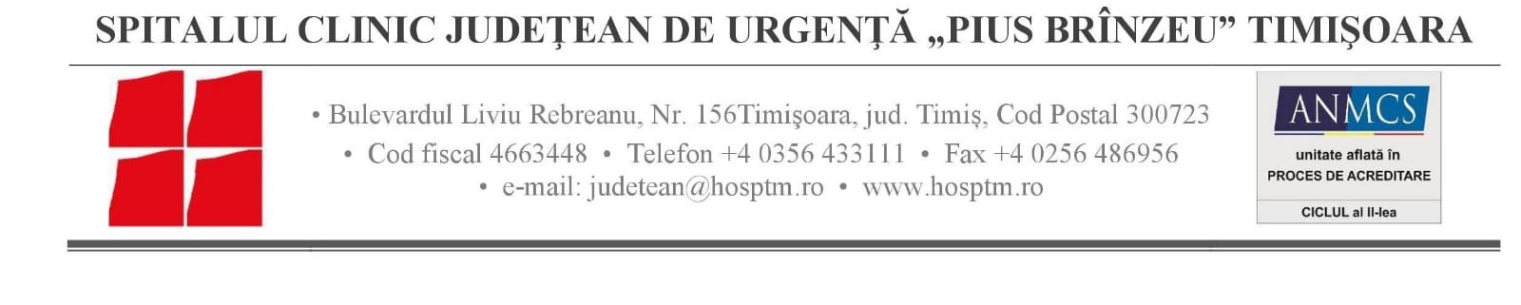

CANCELLATION
OF A SUPPLY TENDER PROCEDURE

TITLE Procurement Specific laboratory reagents for the project “Romania-Serbia joint initiative against cancer in cross-border region: improved diagnosis and treatment of malignant tumors – ROSECAN”

1. Publication reference

RORS-193/1/2022

2. Date of publication

02.02.2022

3. Programme title

Interreg-IPA Cross-border Cooperation Romania-Serbia Programme

4. Contracting authority

Emergency Clinical County Hospital „Pius Branzeu” Timisoara, ONCOGEN, 156 Liviu Rebreanu Blvd., Timisoara City, Timis County, Romania

5. Reason for cancellation

The contracting authority found an omission in the technical specifications for lot no.7, and finds itself in the impossibility of adopting corrective measures without this leading to a breach of the principles of equal treatment between tenderers.
Consequently, the contracting authority cancels the award procedure for lot 7.
Notes:
Should a new tender procedure be launched for this project, a new contract notice will be published, unless the contracting authority awards the contract through a negotiated procedure – in which case only the award of the contract will be published.

